Field 1: The learner experience

Objective 1 – Students and learners
The Coleg aims to work with partners to ensure an increase in the number of students and/or the percentages benefitting from Welsh-medium and/or bilingual provision across the post-compulsory sector.

Higher education

Higher education data report
Since the Coleg was established, there has been an increase in the number of students who study at least part of their degree course through the medium of Welsh today compared to a decade ago. However, over the last 5 years the increase has reached a peak and started to decline slightly. The numbers who study through the medium of Welsh reflect the numbers who can speak Welsh, and between 2021/22 and 2022/23 the total number of students who follow a higher education program in Wales and that have indicated that they can speak Welsh fluently has decreased from 10,470 to 9,645. This is a matter of considerable concern and reflects wider challenges in relation to patterns of participation in higher education in Wales more generally, and the increasing tendency in recent years for more and more students from Wales to be attracted by universities in England.
In view of the fact that there were fewer students who could speak Welsh fluently within the higher education sector in Wales in 2022/23, it is therefore not surprising that the number studying at least 5 credits through the medium of Welsh also decreased. However, the size of the reduction appeared to be significant – from 6,070 in 2021/22 to 5,160 in 2022/23. This could be mainly attributed to the fact that the University of Wales Trinity Saint David has tightened their data collection and reporting processes for students studying through the medium of Welsh. The numbers of students nationally studying at least 40 credits in Welsh also fell slightly - from 2,765 in 2021/22 to 2,445 in 2022/23 (with a large number of those losses again to be attributed to the efforts of some institutions to correct and clean data).
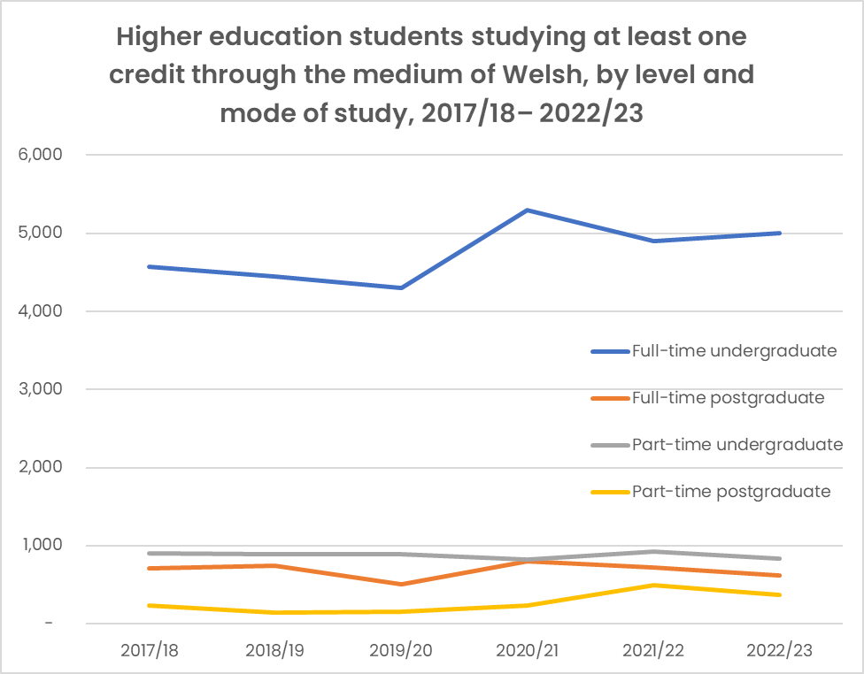
When analysing student patterns between the different levels and methods of study, the Medr Statistics Bulletin, 'Welsh Language in Higher Education 2022/23' shows that the numbers of students who study part-time through the medium of Welsh have continued to decrease (a pattern that has been common across the whole sector in recent years), as well as the numbers of students who study at postgraduate level. However, a small increase from the previous year was seen in the numbers of full-time undergraduate students who study at least part of their course through the medium of Welsh.
The students' language skills are an extremely important factor when looking at the numbers studying through the medium of Welsh. In that regard, care is needed when dealing with the 2022/23 data, as new language categories have been introduced in order to differentiate between students' levels of ability in the Welsh language. It is clear that the new system has led to the return of some unreliable statistics by some institutions. But in the long term, as the new categories become established, this should enable better planning and more effective targeting of efforts. The 2022/23 statistics show once again that the students who consider themselves fluent in Welsh are the most likely to study part of their course in Welsh - with 28% of them studying at least 5 credits through the medium of Welsh, and 20% studying 40 credits or more in Welsh (an increase of 7% from the previous year).
This again underlines the importance of the Coleg's efforts to expand audiences and attract new students to the Welsh-medium provision, and to ensure that students have access to learning opportunities of substance in their chosen subjects wherever they study.

