Coleg Cymraeg Cenedlaethol Annual Report 2024/25
Contents
Part 1: Introduction 2
Foreword by the Chair, Dr Aled Eirug 2
Report of the Chief Executive, Dr Ioan Matthews 3
Part 2: Progress towards the delivery of our Strategic Plan 7
Medr and the Coleg Cymraeg 8
Field 1: The learner experience 10
Objective 1 10
Objective 2 23
Field 2: Provision 36
Objective 1 36
Objective 2 45
Field 3: Employer awareness 54

Part 1: Introduction

Foreword by the Chair, Dr Aled Eirug
It is my pleasure to present my fourth annual report as Chair of the Coleg Board. This will also be the last report I present to the Coleg’s Court as my term as Chair of the Coleg comes to an end at the end of August this year. I am pleased to be able to say once again that the report reflects the Coleg’s impact across a wide range of activities in the tertiary sector. Despite financial challenges in the higher education sector, most Welsh-medium provision has been protected, and following a review of the work in the further education sector, the Board has decided to extend our ambition to ensure that more learners receive Welsh-medium experiences within their studies. Our manifesto proposals have implications that significantly increase our involvement in the field of apprenticeships, while the Coleg’s partnership with schools that offer Welsh-medium sixth form provision has been greatly strengthened. I would like to thank Board members, the Chief Executive and executive directors, senior managers, managers and officers for their diligent work once again this year.
I would like to refer specifically to Llinos Roberts and Pedr ap Llwyd, who are coming to the end of their terms as Board members. Llinos has been Vice-chair for seven years, and stepped up as Chair following the untimely death of Gareth Pierce in 2021. Pedr has served as Chair of the Finance and General Purposes Committee since its formation in 2018; I would like to thank them both for contributing their expertise and experience. The Coleg has just commissioned a governance review, which will ensure a solid foundation for the Board’s work over the next few years.
With the Senedd elections approaching, it is difficult to anticipate what the next few months will bring. But whatever the outcome, the Coleg will publish its new Strategic Plan during the coming year, a plan that will sit alongside Medr’s National Plan for Welsh in the tertiary sector.
In conclusion, I would like to thank the Welsh Government’s ministers and officers for their cooperation, and particularly the Cabinet Secretary with responsibility for the Coleg, Mark Drakeford, and his officers, for their support and interest in our work.

Report of the Chief Executive, Dr Ioan Matthews
With the Coleg Cymraeg about to celebrate its fifteenth anniversary, I am pleased to present this annual report for your attention. As is now customary, the report provides snapshots of the activities that are supported, carried out or planned by the Coleg in partnership with providers in the tertiary sector. It was wonderful to be at the Coleg’s Awards Night once again this year and to celebrate individuals who have made a notable contribution to Welsh-medium tertiary education. A number of them are featured in this report, including the inaugural winners of the ‘Inspiring Others’ award to recognise the excellent work of sixth form pupils in promoting the Welsh language.
While the Coleg’s work has continued to evolve, we are now seeing a number of trends that are likely to have a great influence on policy developments over the coming years.
It is a challenging time in the tertiary sector for a number of reasons, including concerns about the low levels of learner participation in post-compulsory education; budgetary and financial challenges; and demographic patterns leading to a reduction in learner numbers. However, the Coleg has strengthened its partnership with higher education institutions, further education institutions, work-based learning providers and schools, for example by working together on manifesto proposals for the Senedd elections in May.
In several places in the report, reference is made to some of these proposals which, at their core, aim to tackle the sharp reduction in the use of Welsh once learners leave the statutory sector. These include proposals to strengthen the provision and offer for learners in the short term, while some of the structural changes mentioned below begin to take effect. We believe that, more than anything, there is a need for new investment in staffing capacity, and for a significant strengthening of the pathways that will enable learners to use and develop their linguistic skills so that they contribute directly to the vision of a bilingual workforce, and consequently, bilingual workplaces. We will work closely with partners, including the Welsh Language Commissioner and the Athrofa (which will be established in 2027), to make this a reality.
The Coleg has established a close and multifaceted working relationship with Medr (the Commission for Tertiary Education and Research), following our designation to advise it on its statutory duties relating to the Welsh language. Initial formal advice was given in September 2024, as well as advice on regulatory arrangements in October 2025; further advice will be prepared on Medr’s National Plan for Welsh and funding arrangements for Welsh-medium provision. The creation of a robust and ambitious Plan, together with the establishment of appropriate arrangements to acknowledge the true costs of Welsh-medium provision, could enable significant growth in the medium term. As the Welsh Language and Education (Wales) Act 2025’s ambition of increasing the numbers leaving the statutory sector with Welsh language skills is realised, there is an opportunity over the next twenty years to strengthen and enrich the opportunities for learners. In a rapidly changing world, this may be the best opportunity to protect the future of the Welsh language, and the tertiary sector’s contribution to that effort is vital. It is encouraging to feel, for the first time, that there is a growing agreement that the responsibility for this future lies with a multitude of bodies working in partnership under the leadership of the Welsh Government, and not only with organisations such as the Coleg for whom the language is central to their work.
While things will continue to be difficult in the public sector in the next few years, ensuring that progress is made will depend on the decisions of the new government. Once again, I would like to acknowledge the support of officers at the Welsh Language Division and other Welsh Government departments in securing an appropriate budget for this work. Specifically, I would like to thank Bethan Webb, head of the Welsh Language Division for a decade, for her constant support and encouragement.
The Coleg’s Annual Congregation was held in Aberystwyth in March 2024 to recognise the success of research students who have studied for doctorates with the Coleg’s support, and to inaugurate David Jones and Professor Emeritus Eleri Pryse as Honorary Fellows. Professor Geraint H. Jenkins had also received an invitation to be inaugurated as a fellow, but died suddenly in early January. The Coleg was grateful that Ann Ffrancon and the family accepted the fellowship on his behalf in what was a memorable ceremony in Aberystwyth. At the ceremony, we were joined by a number of our Honorary Fellows, including Professor Hazel Walford Davies, who was chair of the Coleg’s predecessor, the Centre for Welsh-medium Higher Education, between 2006 and 2011. As we were preparing this report, we received the news of Hazel’s death. She leaves a large void in the Coleg community, especially for those of us who were part of the journey from the beginning. Her contribution to the complex processes of establishing the Coleg was crucial, and has not yet been fully acknowledged; one day, there will be an opportunity to tell the story. For now: diolch, Hazel, for the constant inspiration and encouragement to persevere with a number of important matters.
My greatest thanks go to my colleagues at the Coleg for their enthusiasm and energy in undertaking their work; it is a privilege to lead such a dedicated team of individuals. Thank you too to the members of the Coleg Board and its committees for their interest and support.

Part 2: Progress towards the delivery of our Strategic Plan
The Coleg Cymraeg Cenedlaethol (the Coleg) launched its Strategic Plan in February 2020. The Plan outlines the Coleg’s vision and values for the period up to 2025 and outlines the strategic priorities in order to deliver the vision. The Coleg’s Board has decided to extend the term of the Plan, and a new strategic plan will be drawn up following the next Senedd elections.
Watch a short film introducing the Strategic Plan.
Our role as a national strategic planning body is to support and influence partners with the resources provided by the Welsh Government to promote post-statutory education through the medium of Welsh.
This annual report shows the progress made by the Coleg and its partners in 2024/25 towards the delivery of the Plan’s objectives across three fields:
- Field 1: The learner experience
- Field 2: Provision
- Field 3: Employer awareness of the importance of bilingual skills

Medr and the Coleg Cymraeg
Medr became operational on 1 August 2024, and the Coleg’s designation to advise it on its duties in relation to the Welsh language has become a key means of achieving our strategic aims.
Medr, the body responsible for regulating and funding the tertiary and research sector in Wales since 1 August 2024, has a duty under the Tertiary Education and Research (Wales) Act 2022 to increase Welsh-medium and bilingual provision in the tertiary sector and to encourage demand for it. In June 2023, the Coleg was designated by the Minister for Education and Welsh Language to advise Medr on this duty.
The designation to advise Medr covers the tertiary education sector as a whole. The Coleg has been planning Welsh-medium and bilingual provision in the higher education sector since 2011 and in the further education and apprenticeships sector since 2019. While we have always worked closely with schools, the relationship with the school sector has been different for a number of reasons. The designation is an opportunity to develop a full understanding of the challenges and opportunities faced by the sixth form sector.
On 4 August 2024 at the National Eisteddfod in Pontypridd, the Coleg and Medr published a Memorandum of Understanding which outlines how the Coleg will advise Medr. Open communication and collaboration are key to realising the ambition of the Act.
The Coleg presented Medr with its first formal advice in September 2024. The advice explains that the Coleg’s vision is that all learners should use, maintain and develop their Welsh skills during their tertiary education or training, and states that Medr should draw up a National Plan for the Welsh language in the tertiary sector in order to realise this vision.
Medr accepted the central recommendation of this initial advice by committing in its first Strategic Plan to develop a National Plan. It has also included the Welsh language as one of its five strategic goals.
Alongside this, a relationship has been established between the boards and officers of the two bodies, and a procedure has been developed for discussing strategic and operational matters.

Field 1: The learner experience

Objective 1
The Coleg aims to work with partners to ensure an increase in the number of students and/or the percentages benefitting from Welsh-medium and/or bilingual provision across the post-compulsory sector.

Higher education

Higher education data report
Since the Coleg was established, we have seen a steady growth in the number of students studying at least part of their degree course through the medium of Welsh. Nevertheless, the official data shows that there has been a decline, on average, over the last five years in the number of students studying at higher education level in Welsh universities and colleges who can speak Welsh. According to the latest published higher education data (for 2023/24) there has been a further reduction in the number of Welsh domiciled students with some level of Welsh language skills – with the total number dropping from 28,040 to 19,190 – and this trend reflects wider challenges faced by the sector, including changes in recruitment patterns and the growing influence of universities outside Wales. It is also important to note that a new approach to measuring students’ language skills was introduced in 2022/23 and that some universities have faced challenges in presenting accurate and reliable data, and there is likely therefore to be some under-reporting in the latest figures.
There are some positive signs in the data for 2023/24 that show the direct impact of the Coleg’s academic strategy. Although the total number of students with Welsh language skills has decreased, as the graph below shows, the percentage of those students studying part of their higher education course through the medium of Welsh has held its ground or increased. The data continues to show that students who consider themselves fluent in Welsh are the most likely to study through the medium of Welsh. 29% of fluent Welsh speakers study at least 5 credits through the medium of Welsh, 21% study at least 40 credits (which is a third of a degree course), and 11% study at least 80 credits (which is two-thirds of a degree course) in Welsh. This slight increase from the previous year reflects the Coleg’s priorities to deepen provision, and to ensure that students have opportunities to study substantially through the medium of Welsh in their chosen subjects. This is positive evidence of the success in terms of planning and the close collaboration with partner institutions, particularly in areas such as Education and Healthcare, which are strategically important areas for the Coleg and where there is a clear need to develop a workforce with strong bilingual skills.
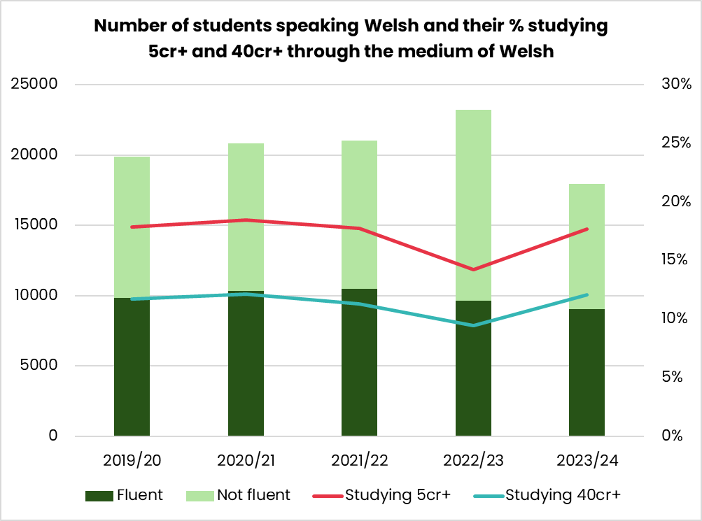
Graph 1: Number of students speaking Welsh and their % studying 5 credits or more and 40 credits or more through the medium of Welsh

In addition, there has been some increase in the percentage of non-fluent students studying some of their higher education course through the medium of Welsh. This also underlines the importance of the Coleg’s efforts to widen access, target new audiences, and ensure high-quality learning opportunities in Welsh across a wide range of subjects and institutions.

Case study 1: Expanding audiences
The Coleg published its latest Higher Education Academic Plan in 2022. In delivering the Academic Plan, the Coleg has implemented a number of exciting projects to expand the audience studying through the medium of Welsh.
Firstly, the Coleg has encouraged all providers to introduce enrolment in Welsh by default in those subjects receiving a Subject Grant. In the past, a number of structural reasons meant that students who had previously studied through the medium of Welsh at school or college were being enrolled on English-medium modules by default. This move will create a smoother and more seamless path for students to be able to continue their studies at university through the medium of Welsh.
A number of institutions have reported on the success of the scheme, as explained by Bethan Wyn, Welsh Language Manager at the University of Wales Trinity Saint David:
“In those departments that implemented enrolment in Welsh by default this year, we’ve seen a retention rate of 100%.”
To complement the process of enrolment by default, the Coleg commissioned Claremont, a behaviour change agency, to create a Behaviour Change Techniques Pack. The pack aims to give guidance and advice to practitioners working with learners who are actively making decisions about their education, with the aim of influencing them to consider studying through the medium of Welsh.
Research also suggests that studying through the medium of Welsh is not a major consideration for many prospective students before they go to university. This has encouraged the Coleg to pilot Welsh language champion positions at Bangor University and Cardiff Metropolitan University. The champions aim to directly influence students’ language choices during their time at university.

Case study 2: Schools tour – Pam Cymraeg? | Why Welsh?
In response to the reduction in the numbers studying Welsh as an AS/A Level subject, the Coleg has arranged a Pam Cymraeg? Why Welsh? schools tour to inspire learners to consider studying the subject.
This year, 30 schools in 14 counties were visited, with over 2,000 learners in year 10 and 11 reached. This included Category 1: English-medium schools; Category 2: bilingual schools; and Category 3: Welsh-medium schools. The visits included panellists discussing the importance of the Welsh language in the workplace and socially; creative workshops; introductions to studying the subject; and musical performances.
Following our visits, several schools are reporting success in recruiting more pupils to study Welsh as a subject. For example, one school has attracted 18 pupils to study Welsh Second Language this year, which is a significant increase compared to last year. One teacher commented:
“We had our open evening for the sixth form last night and it was one of the busiest to date – around 35 pupils showing an interest in studying Welsh as a subject next year! Thank you so much for your support in promoting the subject.”
The Coleg has identified the protection of Welsh as a subject as a priority for the next Senedd term, and in its manifesto for the 2026 Senedd elections, the Coleg is calling on the next government to give Welsh as a subject a special status. The Coleg has also responded to the Qualifications Wales consultation on AS and A Level qualifications in Welsh and Core Welsh, in order to support the development of modern qualifications that appeal to learners.

Case study 3: Sbarduno Scheme
The Coleg’s Sbarduno Scheme is a mentoring scheme for Black, Asian and Ethnic Minority Welsh speakers aged 16 to 19. During the scheme’s second year in 2024/25, fourteen young people received five mentoring sessions through the medium of Welsh. The scheme aims to build the young people’s Welsh language skills, and to encourage them to think about Welsh-medium options in the future. The scheme is a key part of the Coleg’s work in equality, diversity and anti-racism.
Young people have told us that it is important to them that they can speak to Black, Asian and Ethnic Minority role models in Welsh and that this inspires them to work and study through Welsh in future.
One of the young people who has benefitted from the scheme is Leon Edwards-Ohimekpen from Ysgol Gyfun Gymraeg Glantaf in Cardiff. Leon said that the opportunity to be part of mentoring sessions with Ashok Ahir, a Director at Qualifications Wales, motivated him to learn more about the world of work. Leon is now studying Dentistry at Cardiff University, and undertaking part of his course through the medium of Welsh, following a successful period as a prefect at the school.
We look forward to continuing to develop the scheme and to recruiting a new cohort every year.

Post-16 education

Further education and apprenticeships data report
Looking at LLWR 2024/25 data, we see that the Coleg Cymraeg’s initial investment in the further education and apprenticeships sector continues to bear fruit. Investment continues in the fields of Health and Care, Childcare, Public Services, Sports and Land-based Studies, Business and Creative Industries, and there has been new investment in the field of Construction.

Table 1: Teaching activities with at least an element in Welsh
Year | Further education | Work-based learning
2017/18 | 9.6% | 13.4%
2018/19 | 11.9% | 15.4%
2019/20 | 11.8% | 14.6%
2020/21 | 14.7% | 20.8%
2021/22 | 18.2% | 25.3%
2022/23 | 20.6% | 32.7%
2023/24 | 29.4% | 46.6%
Data source: https://www.gov.wales/cymraeg-2050-annual-reports
*The figures have been adjusted compared to the Coleg’s previous annual reports in order to ensure consistency with the Welsh Government’s reporting methods.

Case study 1: Cynnig Cymraeg helps patients
Hanna Griffiths, an NHS healthcare apprentice at Glangwili Hospital, Carmarthen, is an Apprenticeship Ambassador for the Coleg Cymraeg.
Hanna is pursuing a Level 2 Clinical Healthcare Qualification through the medium of Welsh, with the support and encouragement of Lucy Breckon and her tutors at Pembrokeshire College. As a first-language Welsh speaker, Hanna is passionate about using the language every day, especially when communicating with patients on the ward.
Hanna said, “Many of our patients on the ward have dementia or Alzheimer’s disease, which often means they can only communicate in their first language. Speaking to our Welsh-speaking patients in their preferred language is important to make them feel more comfortable.”
Amanda Glanville, Assistant Director of People Development at Hywel Dda University Health Board, added, “I’m very pleased to hear that Hanna has been chosen as an ambassador. It clearly shows her passion for the Welsh language and how important it is to our patients.”
Using Welsh every day is crucial to maintaining and improving Hanna’s skills, so that she can work through the medium of Welsh and talk to Welsh-speaking colleagues, patients and visitors, with the aim of improving their experiences at the hospital. During her time as a Coleg ambassador, she has created a blog and has appeared on S4C’s magazine programme Prynhawn Da as well as its news programme Newyddion to share her experiences on the ward and the importance of using the Welsh language.

Case study 2: Supporting Welsh language creativity
Appointing staff in the field of creative industries has been a key strategic step in strengthening and increasing Welsh-medium and bilingual provision at further education colleges. By ensuring that a member of staff is able to teach and inspire learners through the medium of Welsh, Coleg Cambria has succeeded in creating new opportunities for learners to engage with their courses bilingually and to see how the Welsh language is a practical, relevant and integrated part of their creative field.
Magi Roberts, who has completed her level 3 qualification in creative media production, is a notable example of the positive impact of this provision. She had the opportunity to take part in workshops, projects and work opportunities through the medium of Welsh, which ensured that she developed her creative skills in both languages. She had the opportunity to be one of the Coleg’s national ambassadors, playing a leading role in promoting the use of Welsh among her peers in their subject area.
We see a similar story at Coleg y Cymoedd, where they are very proud of Luca McAlpine, a Creative Media student, who won the Coleg’s William Salesbury Further Education and Apprenticeship Award. Luca uses the Welsh language creatively and contributes to the social and cultural life of the college, displaying Welsh language artwork and volunteering at events. During the National Eisteddfod in Pontypridd, Luca was one of the main volunteers on the college’s stall, ensuring a strong presence at the festival.
The award recognises Luca’s contribution to Welsh language life at the college, especially within the LGBTQ+ community, where Luca promotes inclusion and support through the medium of Welsh.

Case study 3: Sixth form pupils excel at the Coleg’s Awards Night
The Coleg Cymraeg’s Awards celebrate individuals from all parts of the education sector, from schools to apprenticeships, for their contributions to Welsh-medium education. This year, a new ‘Inspiring Others’ award was introduced, to recognise school pupils for their inspiring work encouraging their classmates to use the Welsh language.
Aminata Jeng from Ysgol Gyfun Gymraeg Llangynwyd was awarded for her extraordinary work in the field of equality and the Welsh language. Amie said:
“As a member of my school’s Equality Committee and as a school ambassador for the Coleg, I am proud of my Welshness and take every opportunity to challenge the stereotypes attached to the language. I often express my views and propose new ideas in order to increase equality within the school and locally, all through the medium of Welsh.”
Jacob Simmonds from Ysgol Gymraeg Gwynllyw received an award for his innovative work in promoting the Welsh language among his peers and younger learners at the school, as well as young people with educational and social needs. Jacob said:
“Winning this award is a huge honour. This recognition has given me a boost to continue using and promoting Welsh. In the future, I hope to work as an Additional Learning Needs teacher to ensure that all pupils have equal opportunities to learn and use Welsh.”

Objective 2
The Coleg aims to work with partners to ensure high-quality Welsh-medium and bilingual provision. Ensuring high-quality resources enriches the provision.

Higher education

Higher education data report
It is important to be able to measure and evaluate the quality of the Welsh-medium provision offered to students, and universities do this by collecting student feedback at module and degree scheme level. The annual NSS survey is also an opportunity for students to give their views on the quality of the provision and the learning experiences they receive. Within the Coleg’s own operations, we have a Student Forum that meets every term and includes representatives from each of the higher education providers in Wales, where they have the opportunity to air and discuss all aspects of the student experience at the university, including the quality of the provision. Items from the Student Forum are presented to the Coleg’s Academic Board meeting each term, which also includes student representatives from each of the higher education providers.
The results of an interesting study by Dr Rebecca Ward from the University of South Wales, supported by a Coleg Small Grant, were published in Gwerddon Fach during the year. The study investigated the results of studying through the medium of Welsh in higher education. This was done by analysing degree and module results, and speaking directly to students and graduates about their experiences. The study looked at a sample of 32,388 university students studying in Wales between 2019 and 2022. Some of the results are summarised in the following graphs.
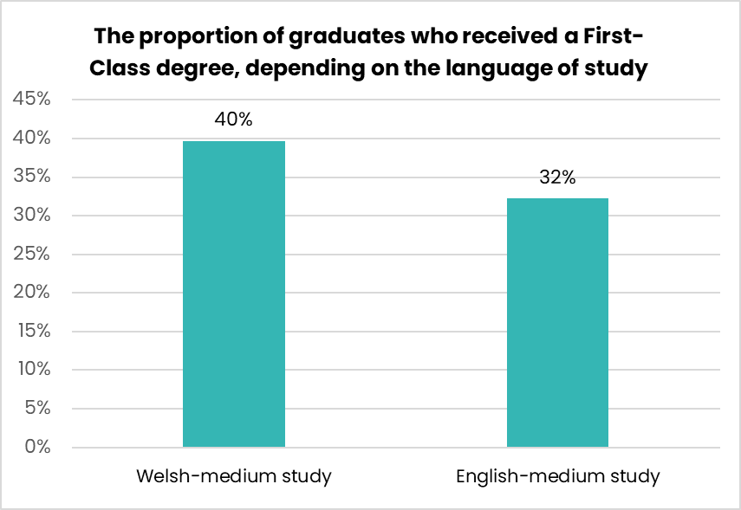
Graph 2: The proportion of graduates who received a First-Class degree depending on the language of study. Welsh-medium study = 5cr or more through the medium of Welsh

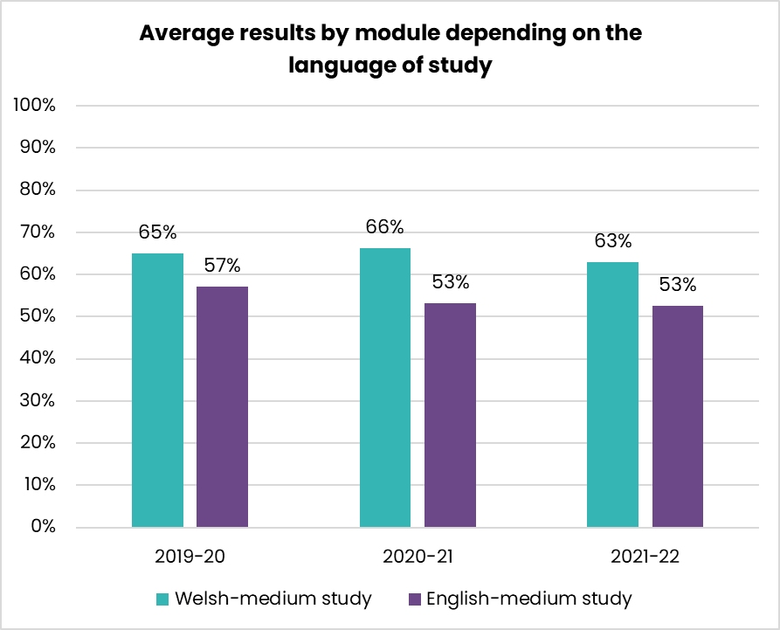
Graph 3: Average results by module depending on the language of study. Comparisons were made between the average mark of students studying a Welsh-medium module and the average mark of those studying the corresponding module in English
The statistics are striking and suggest that the quality of Welsh-medium education at university can offer significant academic advantages. Of course, other factors can also influence academic performance, e.g. economic background, and it would be useful to consider this in a further study.

Case study 1: Developing high-quality Sociology materials for the benefit of students studying the subject across Wales
With the support of the Coleg and HEFCW’s Investment and Recovery Fund, Social Sciences lecturers throughout Wales worked together to prepare high-quality resources that will be of practical use to students who are studying the subject. Three years since the publication of the two units ‘Astudio Cymru Gyfoes’ (studying modern Wales) and ‘Theori Gymdeithasegol’ (sociological theory), these resources are widely used by universities.
Dr Siôn Jones from Cardiff University reports,
“An entirely Welsh-medium module has been introduced in the second year – ‘Cymdeithas Gyfoes yng Nghymru’ (contemporary society in Wales) – which is based on the resources of ‘Astudio Cymru Gyfoes’. These are high-quality resources that include a lecture in the form of video presentations, a multiple choice quiz, and seminar questions.”
Dr Cynog Prys from Bangor University added,
“I have used a few sessions in the form of an entire video within my Welsh-medium sociological theory modules. This has enriched the students’ learning experience by giving them access to the specialist subjects of Welsh-medium colleagues at other universities.”

Case study 2: Bilingual excellence in the media: pioneering lecturer honoured
It was a pleasure to present the Coleg’s Celebrate Your Lecturer Award to Dr Non Vaughan Williams, Senior Lecturer in the Department of Media and Communication at Swansea University. The award recognises her ongoing commitment to promoting high-quality Welsh-medium provision, creating opportunities for students to develop professionally and personally in their language.
Dr Williams has played a key role in developing pioneering modules that respond directly to the needs of the media industry in Wales, ensuring that the future workforce has the bilingual skills that are essential to the Welsh economy. By establishing a panel of experts, she has enabled strategic collaboration between academia and the media sector, creating clear pathways for students to internships and work experiences.
According to Cara Walters, a student at Swansea University:
“Dr Non Williams has made a significant difference to the learning experiences of Welsh language students across the institution. Her enthusiasm is inspiring, and her teaching has ensured that all students have the opportunity to develop employability skills through the medium of Welsh which will help them to develop professionally.”

Case study 3: Podcasts that inspire debate – Professor Carwyn Jones wins an award
The Coleg’s award for an Excellent Welsh-medium Resource was won this year by Professor Carwyn Jones from Cardiff Metropolitan University’s School of Sport and Health Sciences, for creating a series of podcasts on sports ethics. The podcasts deal with several important and contemporary topics, such as racism and racial stereotypes in sport, the rights of transgender athletes, fairness, sportswashing, role models and nationalism, and enable students to discuss the subject at an advanced level through the medium of Welsh. The project led to work on the standardisation and establishment of terminology, and a glossary and a series of notes have been prepared to accompany each of the discussions.
“The award is a source of real pride,” said Professor Carwyn Jones, “and an acknowledgement of the important Welsh-medium work being done in our School. It was a challenge to coordinate the project’s various elements, but I hope the resource will support students and introduce a new audience to sports ethics.”

Case study 4: Celebrating research by women
To celebrate International Women’s Day on 8 March 2025, a virtual special edition of Gwerddon was published that celebrates research and scholarship by women.
This issue brings together a selection of articles by women that have been published in Gwerddon over the last eighteen years. The editors chose six articles on very different topics, and a foreword was written by Professor Menna Elfyn.
Professor Anwen Jones, editor of Gwerddon, said:
“The aim of the Gwerddon editorial board in bringing this special edition together is to bring to light the range of scholarly expertise of women publishing in Welsh, and the key role they play in the crucial dialogue taking place within the virtual pages of our journal. Thank you to the women of Wales for all your contributions.”

Post-16 education

Further education and apprenticeships data report
There were over 57,000 visits to further education and apprenticeships resources on the Porth Adnoddau this year, with the majority once again visiting Prentis-iaith resources. The data shows a strong focus on developing language skills in the sector, with the nine most popular resources being related to introducing new terminology. We were pleased to see that use is also being made of Teclyn Iaith (Welsh Toolkit), a resource to increase staff awareness of the digital tools available to support them in providing bilingual education. We were also pleased to see that a number of the most popular resources have been developed by our partners, such as ‘Say it in Cymraeg’, a resource developed by Adult Learning Wales, and the Resources for Learning and Teaching Welsh as a Second Language which were led by ColegauCymru.
Table 2: The Porth’s most popular resources
 | Most popular collections | Number of hits
1 | Prentis-iaith Awareness Level | 34,704
2 | Prentis-iaith Understanding Level | 9,332
3 | Prentis-iaith: Level Identification Quiz | 3,833
4 | Prentis-iaith Fluency Level | 1,520
5 | Prentis-iaith Confidence Level | 1,127
6 | Language Mats | 611
7 | Say it in Cymraeg | 452
8 | Resources for learning and teaching Welsh as a second language (formerly Cynllun Colegau Cymru) | 227
9 | Construction Terminology | 193
10 | Teclyn Iaith (Welsh Toolkit) | 163
Provision in the field of Construction was funded for the first time this year. This had a significant impact on the use of resources in this area, attracting the third largest number of visits after Health and Care and Childcare. In addition, we were pleased to see that new resources, such as the Cit Chwaraeon sports resource, are being used, as well as favourites such as ‘Sbia ar Hwn’, which was also the most popular resource in the creative industries last year.
Table 3: Resources by Priority Subject
Subject Area | Number of  hits | Most popular resources within the field apart from Prentis-iaith
Health and Care | 2,389 | Bilingual Vocabulary Posters: Health and Care
Childcare | 1,634 | Childcare Case Studies: Including Every Child
Business | 437 | Business Studies
Agriculture | 1,141 | Hwb: Agriculture Resources
Sport | 417 | Cit Chwaraeon
Public Services | 841 | Ap Chwaraeon Trwy’r Gymraeg (Sports through the Medium of Welsh App)
Construction | 1,602 | Construction Terminology
Creative Industries | 428 | Sbia ar Hwn

Case study 1: Webinar for middle managers: improving the quality of Welsh-medium provision in the further education and apprenticeships sector
A Coleg-led webinar for middle managers in the further education and apprenticeships sector was held in February 2025. The session’s aim was to share experiences and good practice relating to expanding high-quality bilingual and Welsh-medium provision. During the session, contributions were received from four curriculum area managers who discussed their methods of planning and incorporating Welsh-medium provision within their departments. The discussion was chaired by Yusuf Ibrahim, Assistant Principal – Higher Education, Academic Studies, Foundation and Adult Learning at Cardiff and Vale College.
The panel included:
- Lucy Breckon, Work Based Learning Manager (Health Care and Commercial Enterprises) – Pembrokeshire College
- Rhian Pardoe, Health and Care Learning Area Manager – Gower College Swansea
- Amy Thomson, Sports and Public Services Programme Area Manager – Grŵp Llandrillo Menai
- Rachel Lewis, Construction Curriculum Manager – Bridgend College
Valuable insights were gained into good practice on successfully planning high-quality Welsh-medium provision within departments. Practical examples were shared of how the planning work is implemented effectively, and how this contributes to the quality of the teaching, and there were discussions on the response of staff to these developments, highlighting the positive impact on awareness and internal support.
The session was viewed live by over thirty managers from the sector, reflecting a high level of interest and commitment to developing Welsh-medium provision and ensuring a high-quality experience for learners. In order to ensure continued access to the content, the webinar has now been uploaded to the Porth Adnoddau, enabling more staff to engage with the discussions, learn from the panellists’ experiences, and consider how to implement good practice in their own contexts.

Case study 2: Using digital approaches to improve the quality of Welsh-medium and bilingual provision
Each year, training sessions are provided by independent e-learning consultant Mary Richards, with a total of 641 staff members from the sector participating during the 2024/25 academic year. These sessions are an opportunity for staff to develop their understanding of how to use reliable, high-quality technology to introduce more Welsh in their lessons and sessions. Participants also had the opportunity to discover effective ways of finding and successfully integrating high-quality bilingual and Welsh-medium resources into their everyday teaching.
This intervention, organised by the Coleg, has developed the awareness, understanding and confidence of staff to use technology to improve the quality of their provision, and they are happier and more able to use Welsh naturally in their teaching, creating an environment that supports and encourages consistent use of the language.

Case study 3: Cit Chwaraeon
The Coleg’s new resource for students studying Sport level 2 was launched on the Coleg Cambria stand at the National Eisteddfod in Wrexham. The resource, ‘Cit Chwaraeon’, which was authored by former sports lecturer Simon Evans, includes a variety of videos from those pursuing a career in sport, including football star Lili Mai Jones who plays for Wrexham, and para athlete Tomi Roberts-Jones.
Emyr Phillips, Scarlets Academy Pathway Manager and Scrum Coach, who is also part of the resource, said:
“I’m very proud to have contributed to this resource, helping to develop the sports leaders of the future. It’s also great that the resource is available in Welsh, and that young people studying courses in further education colleges have a new resource to support their learning.
“I’ve used a lot of Welsh on the playing field, as a player and as a coach, and it’s important that we show young people how useful it is to speak both languages if they’re considering working in the sports industry.”

Case study 4: Enhancing the impact of a new resource through collaboration with YFC
The Young Farmers Clubs rural affairs committee breakfast at the Royal Welsh Show in July was the setting for the launch of the Coleg’s new resource, Cynhyrchu Cig, a resource for agricultural learners at all levels, but mainly at levels 2 and 3, on how to produce quality lambs and cows for the meat market.
Lora Jên Pritchard, Coleg Cymraeg ambassador and Agriculture learner at Coleg Glynllifon, said:
“The resource is great because it conveys information in an interesting, visual and engaging way.
“By reading, watching and listening to meat producers from different companies sharing their experiences and expertise, you can learn a great deal about the industry.
“There are over 65 lessons on the resource, so plenty to keep you engaged, and my favourite parts are the activities at the end that challenge you.” The resource is divided into 14 units – with seven units focusing on lamb production and seven on beef production – and features television series Busnes Bwyd star Matthew Rees from Albert Rees butchers, Carmarthen.

Field 2: Provision

Objective 1
Working with partners, the Coleg aims to make Welsh-medium and/or bilingual provision available in as many subject areas as possible for higher education, and available in the areas identified in the Action Plan for further education and apprenticeships.

Higher education

Higher education data report
There has been a significant increase in the number of subjects that can be studied through the medium of Welsh since the Coleg was established. There is some provision in Welsh in each of the 36 ‘main subject groups’ listed in the Coleg’s Higher Education Academic Plan, compared to 12 in 2011.
Within the 36 ‘main subject groups’, there are 80 academic subjects. It is now possible to study at least 5 credits through the medium of Welsh in at least one institution in 76 of these subjects.

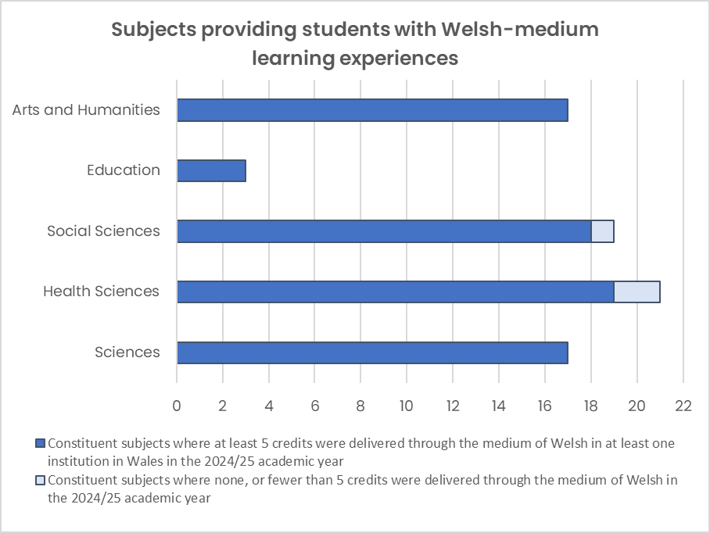
When reporting to HESA, there is a special category called ‘Combined’ which includes three different constituent subjects that are not represented in the graph. According to recent data, Welsh-medium provision exists in two of these constituent subjects across several institutions.
Graph 4: Subjects providing students with Welsh-medium learning experiences
It is also possible to study extensively (i.e. at least 40 credits a year) in 68 of these academic subjects in at least one institution.
The Coleg continues to seek opportunities to support new Welsh-medium provision, and provides Catalyst Grants and Interdisciplinary Grants in several places in order to stimulate these developments, such as Chemistry (Cardiff University), Veterinary Science (Aberystwyth University), Health Professions (Wrexham University) and Medicine (Bangor University). The latest discipline to receive Coleg investment is Planning at Cardiff University.
Table 4: Higher education subjects providing students with Welsh-medium learning experiences
 | Main subjects | Constituent subjects
Arts and Humanities | 7/7 | 17/17
Education | 2/2 | 3/3
Social Sciences | 8/8 | 18/19
Health Sciences | 8/8 | 19/21
Sciences | 9/9 | 17/17
Personal development and others | 2/2 | 2/3

Case study 1: Supporting medical provision that responds to the needs of the community
Since 2018, it has been possible to study Cardiff University’s Medicine programme at Bangor University, but in September 2024, Bangor University launched its own full medicine programme with the aim of creating meaningful and sustainable provision in Welsh from the outset. Following the establishment of a Medical School at Bangor University, students can now undertake their entire medical studies in north Wales if they wish, and the first cohort will graduate in 2028.
One of the core reasons for establishing the course is to increase the number of doctors practising in the north. In order to increase the number of Welsh-speaking students undertaking the Medicine course, the University has adjusted the entry requirements to allow conditional entry grades of AAB for Welsh speakers. By combining this with support for the Coleg’s ‘Doctoriaid Yfory’ (Tomorrow’s Doctors) scheme, the University is confident that it will see a significant increase in the number of Welsh speakers studying Medicine in Bangor.
In addition, the Coleg provides the University with a Catalyst Grant to support the development of Welsh-medium provision for every learner studying Medicine in Bangor. This support is a key part of the strategy to strengthen the use of Welsh in the medical field, ensuring that students have opportunities to develop their language skills in a clinical context.
According to Dr Nia Jones, Deputy Head of North Wales Medical School, “At the beginning of their medical studies, every single student receives a ‘More than just words’ session once a week for a year. From the feedback we gather, it is encouraging that students have said that these ‘More than just words’ sessions have influenced them to stay in Wales to work.”
By strengthening the Welsh-medium provision and putting the patient’s needs first, the course prioritises principles that are at the core of the Welsh Government’s ‘More than just words’ plan.

Post-16 education

Further education and apprenticeships data report

Further education colleges were provided with £2,234,080 to increase Welsh-medium and bilingual provision in 2024/25. Development grants were awarded to 12 colleges as follows:

Table 5: Further education development grants
Subject area | Institution
Skills | Adult Learning Wales
Childcare  Health and Care  Public Services  Sport  Business  Creative Industries  Construction  Teaching Support Workers | Cardiff and Vale College
Childcare  Health and Care  Public Services  Sport  Land-based Studies  Business  Construction  Creative Industries | Coleg Cambria
Childcare  Health and Care  Public Services  Sport  Land-based Studies  Business  Creative Industries | Coleg Gwent
Childcare  Health and Care  Public Services  Sport  Business  Creative Industries  Construction  Teaching Support Workers | Gower College Swansea
Childcare  Health and Care  Public Services  Sport  Business  Creative Industries  Construction | Merthyr College
Health and Care  Public Services  Sport  Business  Creative Industries  Construction | Bridgend College
Childcare  Health and Care  Public Services  Sport  Land-based Studies  Business  Creative Industries  Construction | Pembrokeshire College
Childcare  Health and Care  Public Services  Sport  Land-based Studies  Business  Creative Industries  Construction | Coleg Sir Gâr / Coleg Ceredigion
Childcare  Health and Care  Public Services  Sport  Business  Creative Industries  Construction | Coleg y Cymoedd
Childcare  Health and Care  Public Services  Sport  Land-based Studies  Business  Creative Industries  Construction | NPTC Group of Colleges
Health and Care [2 grants]  Sport and Public Services  Land-based Studies  Business  Creative Industries  Construction | Grŵp Llandrillo Menai

In the apprenticeship sector, £429,600 was allocated to apprenticeship providers to increase Welsh-medium and bilingual provision in 2024/25 in the priority areas.
Table 6: Apprenticeship Development Grants
Subject area | Provider
Childcare  Supporting Learning and Teaching | ACT
Health and Care  Childcare | ITEC
Hospitality  Management | Cambrian Training
Health and Care  Childcare | Educ8
Skills Hub | Urdd
Data source: Development grant data 2024/25

Case study 1: Classroom provision to help patients
Grug Ryan is a Health and Care lecturer on Y Graig campus (Llanelli) at Coleg Sir Gâr. In order to ensure that her students develop their language skills in line with their ability, Grug worked with the Department of Health and Care to ensure that the department’s tutorial groups were divided according to language ability. An expectation was placed on the Welsh language group that they would undertake their written classwork through the medium of Welsh, giving them the clear message, ‘you are here to retain your Welsh language skills!’
As well as ensuring that her learners make extensive use of Welsh in the classroom, Grug strives to ensure that learners use their Welsh on work placements by pairing learners with a Welsh-speaking mentor in the workplace.
Grug said:
“The Welsh language is so important in Health and Care, and makes such a difference to patient care. I’m determined that my students should have every opportunity to reinforce and develop their skills while they are in college, as it will not only help them in their careers, but will also benefit the patients who are in their care.”

Objective 2
By working with partners, the Coleg aims to ensure the availability of the necessary number of staff to maintain Welsh-medium and/or bilingual provision.

Higher education

Higher education data report
Over the last five years, the number of university staff recorded as being able to teach through the medium of Welsh has decreased. This undoubtedly reflects the difficult period that has faced the higher education sector in recent years – a situation that is likely to continue for some time yet. The reorganisation plans seen at several universities over the last 18 months, with redundancy schemes and a number of staff taking early retirement or leaving the sector, have included some staff who taught through the medium of Welsh. As a result, it is very likely that a further reduction will be seen in the official data when the bulletins for 2024/25 and 2025/26 are published.
The Coleg constantly monitors the numbers of staff who can teach through the medium of Welsh, and assesses the impact of this on the provision and the learning experiences available to students through the medium of Welsh. It is worth noting that the numbers of staff in the higher education sector who have been contracted to teach through the medium of Welsh have remained consistent in the last year and there has been no decrease between 2022/23 and 2023/24. However, the Coleg will continue to advise Medr on the importance of maintaining, protecting and increasing staffing resources. The Coleg has identified the need to increase Welsh-medium staffing levels across the tertiary sector as a priority for the next government, and is calling on the political parties to provide the Coleg with additional funding for this purpose.
The Coleg continues to support many academic departments at the universities and colleges via initiatives such as the Subject Grants, the Catalyst Grants and the Interdisciplinary Grants. Since its launch in 2018, the Coleg’s Associate Lecturer scheme has gone from strength to strength and now has over 600 members.
As well as supporting provision and the staffing community, the Coleg also continues to invest in the development of the next generation of university lecturers and researchers. In 2025, the Coleg celebrated 20 years since the launch of the Research Scholarship Scheme. The purpose of the scheme is to fund PhD students who carry out their research through the medium of Welsh. Since its launch, the scheme has supported around 190 postgraduate students studying for a PhD. A number of them have gone on to lecturing positions at universities and now teach through the medium of Welsh.
Table 7: Staff who teach in Welsh
 | Teaching in Welsh (full person equivalent)
2014/15 | 625
2015/16 | 590
2016/17 | 630
2017/18 | 485
2018/19 | 600
2019/20 | 595
2020/21 | 580
2021/22 | 555
2022/23 | 565
2023/24 | 565
Source: StatsWales: ‘Higher Education teaching staff in Wales by ability to teach through the medium of Welsh and whether contracted to teach through the medium of Welsh’

Case study 1: Celebrating 20 years of research scholarships
In 2025, we marked 20 years since the establishment of the Coleg’s Research Scholarship Scheme, which supports students to study for a doctorate through the medium of Welsh.
The aim in establishing the scheme was to develop first-rate researchers who can work through the medium of Welsh. As a result, we now have an energetic group of academics working in universities across Wales, carrying out pioneering work, and increasing and developing Welsh-medium provision for students.
Each year, a programme of research skills training is organised, which is specially tailored to support and give practical training to scholarship holders and other research students.
Since the scheme was established in 2005, over 190 PhD scholarships have been funded in various fields. Over half the scholarship holders secured academic posts after graduation.
One of the first to receive a scholarship was Dr Hywel Griffiths, Reader at Aberystwyth University’s Department of Geography and Earth Sciences.
Hywel said, “Incredible progress has been made since the Research Scholarship Scheme was established. I’m very happy to see the Research Skills Programme going from strength to strength, equipping students with the skills to enter the world of research or lecturing.”

Case study 2: Professor Jonathan Scourfield, Cardiff University: Professor of Social Work and Deputy Director of CASCADE
Professor Jonathan Scourfield joined the Cymraeg Gwaith scheme in 2024, with the aim of developing his use of Welsh to deliver provision to Social Sciences students through the medium of Welsh.
He had completed an Advanced and Proficiency Course in the past, and this time he was keen to develop his Welsh language skills in ways that were more specific to Welsh-medium provision. Specifically, Jonathan wanted to develop a range of language registers for use in work, and in order to do so he practised presenting the same piece of information to three different audiences.
Another aim of his was to improve his ability to understand spoken Welsh from different parts of the country, since a variety of dialects are spoken by students studying Welsh-medium modules as part of their degrees at the School of Social Sciences.
He is very enthusiastic about increasing the use of Welsh on the University campus, including seeing more students choosing to undertake Welsh-medium modules. To that end, he organises and supports informal learning events for staff and students.

Post-16 education

Further education and apprenticeships data report
Data about the staffing position in the further education and apprenticeships sector is published every year by the Education Workforce Council, and the data for 2025 shows an increase once again in the number of further education staff who speak and use Welsh at work. A reduction was seen in the number of work-based learning practitioners generally, but the reduction among Welsh speakers was less acute, which means a slight increase in the percentage of staff in the sector who can speak Welsh.
Table 8: Staff who can speak and are teaching through the medium of Welsh
 | 2020 | 2021 | 2022 | 2023 | 2024 | 2025
Welsh-speaking staff (FE) | 1,095 | 1,083 | 1,120 | 1,160 | 1,204 | 1,241
Welsh-speaking staff (Apprenticeships) | 456 | 435 | 432 | 476 | 558 | 550
Staff teaching in Welsh (FE) | 764 | 771 | 789 | 814 | 860 | 902
Staff teaching in Welsh (Apprenticeships) | 314 | 313 | 321 | 355 | 425 | 417
Data source: Education Workforce Council: Annual Statistics of the Education Workforce in Wales 2025. Section 3: Further education sector (p. 8 FE, p. 26 WBL)

Case study 1: The benefits of mentoring to increase Welsh language opportunities
During the 2024/25 academic year, 51 individuals from 22 institutions took advantage of Sgiliaith’s national mentoring scheme. This programme gives education practitioners one-to-one support, encouraging them to reflect on their current approaches to learning, teaching and assessing bilingually, and supporting them to adapt and strengthen those practices.
Clear improvement was seen in the confidence and motivation of staff in:
- preparing bilingual teaching resources;
- teaching and assessing bilingually;
- exploring new ways of incorporating the Welsh language into their practice.
There has also been a significant increase in practitioners’ awareness and understanding of LA26 codes, which is the method of measuring how many learning activities have been provided with an element of Welsh and the resources available to support them. As a result, staff felt more confident to offer their learners bilingual assessments.
According to Sam Howes, a practitioner with Achieve More Training,
“My level of Welsh has improved, and I feel more motivated to help others develop their language skills. Before receiving the support, I used Welsh occasionally, but now I use it regularly. I achieved my targets, and I believe Achieve More Training is now a more inclusive place with more bilingual resources.”

Case study 2: Developing bilingualism for the business world
The appointment of Jacques Mahé as Welsh Language Facilitator in the Business Department at Coleg Gwent has contributed significantly to the development of Welsh-medium provision within the department. As a result of this appointment, which was made following funding from the Coleg, the Welsh language is now more naturally and meaningfully integrated into the Business curriculum, with its presence strengthened across learning activities.
Learners have responded enthusiastically to the challenge of incorporating the Welsh language into their work, including adding Welsh language elements to visual marketing displays and creating bilingual business plans, which has given them the opportunity to express their ideas confidently in both languages and to develop communication skills and creativity.
Jacques’ influence on the department’s teaching staff has been crucial – the team now encourages Welsh language participation by learners, especially those learning Welsh as a second language. The response from learners has been very positive, with a recognition of the value of the Welsh language and of opportunities to use the language in professional contexts. The feedback gathered from learners shows a high level of satisfaction with the new bilingual curriculum, with the majority scoring it very highly.

Case study 3: Cymraeg Gwaith supports bilingual provision
Arfon Roberts has been an Engineering Lecturer at Coleg Menai for 25 years. He grew up in Holyhead, but after leaving school he did not use his Welsh at home or in the workplace.
After moving to the Llangefni campus, Arfon noticed many more students speaking Welsh in class, with many of them being first language Welsh speakers. At one point, he was lecturing to four level 2 classes, and all of the students were first language Welsh speakers, so he decided to join the Cymraeg Gwaith lessons.
Arfon attended two years of lessons at Intermediate level, and started Advanced level lessons in September 2025. He has gained a great deal of confidence through his Cymraeg Gwaith lessons, and now, the language of the class is Welsh. Students are able to email him and communicate with him in Welsh and discuss terms bilingually, and he can offer an explanation of any new terminology, switching easily from one language to another. This has been very beneficial for Arfon’s students, and he is glad that they no longer need to switch to English to have discussions with him.
Arfon is keen to encourage colleagues to join the Cymraeg Gwaith course, and emphasises that it is never too late to develop your Welsh language skills!

Field 3: Employer awareness
The Coleg aims to work with others to increase awareness among employers of the importance of bilingual skills and Welsh language skills.

Case study 1: Welsh Language Healthcare Forum
In 2022, the Welsh Government renewed ‘More than just words’, its strategy to increase the number of bilingual staff working in the NHS.
With that in mind, Swansea University organised a National Welsh Language Healthcare Forum with support from the Coleg’s Collaborative Fund. The Forum was held on 15 May 2025 at Swansea University, with the aim of bringing key partners together to discuss the importance of increasing the bilingual skills of the health workforce.
The day’s programme included speakers from the Welsh Government, NHS Health Boards, Health Education and Improvement Wales (HEIW), Digital Health and Care Wales (DHCW), the Welsh Language Commissioner, County Councils and Swansea and Bangor universities. It was an opportunity to discuss ways of increasing awareness of the importance of the health workforce’s bilingual skills in order to respond to the targets of ‘More than just words’. A session was organised to discuss workforce planning, with a presentation from Ifan Evans (DHCW) on NHS digital systems, and from Simon Cassidy (HEIW) on the use of placements as an approach to teaching.
Dr Alwena Morgan, Leader for Welsh in the Faculty of Medicine, Health and Life Science at Swansea University, and organiser of the event, said, “The day was a great opportunity to create new connections and to strengthen the network of officers with responsibility for Welsh in healthcare, and it inspired a second ‘More than just words’ conference which was held by the Welsh Government some time after our conference in October 2025.”

Case study 2: Solicitors Qualifying Examination provided in Welsh
The introduction of the Solicitors Qualifying Examination (SQE) is the biggest change in solicitor training for almost 30 years, and it completely replaces the traditional route of the Legal Practice Course. Thanks to the influence of the Coleg’s Law Panel, it is now possible for students to sit the SQE in Welsh. Panel members brought their influence to bear and took part in discussions with the Solicitors Regulation Authority and Kaplan, the company that provides the exams, supporting them to carry out research to seek the views of students and to prepare the exams in Welsh.
Chair of the Law Panel, Dr Huw Pritchard, said,
“Developing the professional exams for solicitors in Welsh means that it is now possible for prospective solicitors to undertake their education bilingually throughout their legal studies. As a panel, we look forward to continuing to support students to carry out their studies in Welsh from the beginning to the end of their training, and in their practice of law.”

Case study 3: Launch of Pecyn Prentis
During the year, we saw the launch of Pecyn Prentis – a new resource that supports the provision of bilingual apprenticeships in Wales. Pecyn Prentis offers a one-stop shop for employers, training providers and anyone involved in apprenticeships, and provides practical guidance, expert advice and real-life success stories.
The resource is designed to reflect and reinforce the sector’s commitment to the recruitment and support of Welsh-speaking apprentices. It contains inclusive strategies and useful resources that promote the use of Welsh in the workplace, and is aligned with the aims of the Welsh Government’s national language strategy, Cymraeg 2050.
As an essential part of the development process, a focus group of employers was established to ensure that the sector’s voice was heard. This group was key to understanding the real needs of employers, gathering good practice, and exploring how Welsh-speaking apprentices are supported. Through these discussions, a solid foundation was created for a practical resource that responds to the growing demand for bilingual skills in the workplace.
Pecyn Prentis is now publicly available, and offers great support for anyone who wants to start or strengthen their bilingual apprenticeship journey.

Thank you for your interest in the Coleg’s work.

As a result of the changes in 2022/23 to the method of recording and reporting student numbers in terms of their linguistic ability, there was a significant increase in the number of students who were returned as Welsh speakers but with ‘unknown ability’ (4,825 were recorded in this category, of which 3,720 were students at the University of South Wales). This was the main reason for the large increase seen in the total number of students returned with some skills in the Welsh language in 2022/23. Following efforts to improve data quality by the 2023/24 return, a significant decrease was seen in the total number of students with some skills in the Welsh language. However, this data is unlikely to be completely accurate either, since some providers returned a significant number of students whose language skills were not known at all – although many of them, most probably, have some ability in Welsh. (The University of South Wales in 2023/24 returned 4,085 students whose language skills were ‘unknown’ – a significant increase from 1,465 the previous year, but with a corresponding drop from 3,720 to only 215 students recorded as Welsh speakers but fluency unknown.)

