Coleg Cymraeg Cenedlaethol Conference 2023
  - A conference for university lecturers and practitioners in the further education and apprenticeship sectors.

10.15 Registration and refreshments

10:30 Welcome – Chair of Coleg Cymraeg, Dr Aled Eurig

10:35 Keynote Speaker
Efa Gruffudd Jones, Welsh Language Commissioner

11:00 Session 1 (open to all)
Changing behaviour: encouraging and motivating students and learners to study through the medium of Welsh

• Heledd Bebb, OB3 Research.
• Dr Kelly Young, Prifysgol Metropolitan Caerdydd;
• Dr Osian Elias, IAITH: Y Ganolfan Cynllunio Iaith

12:30 - 13:30 Lunch and networking

13:30 - 14:20 Session 2
Moving Forward: Transition and progression between sectors.
(A session for higher and further education practitioners)
• Dr Rhian Hodges, Bangor University;
• Anna Davies, Gower College
• Menna Jones, Coleg Sir Gâr

Taster session – resources
(A bespoke session for apprenticeship providers).

14:30 - 15:20 Session 3
Nurturing confident bilingual graduates
(A session for university lecturers)

• Dr Dylan Foster Evans, Prifysgol Caerdydd;
• Dr Mirain Rhys, Prifysgol Metropolitan Caerdydd.

Progress up the pyramid
(A session for practitioners in the further education sector and apprenticeship providers)

- Meggan Prys, Sgiliaith
- Marion Evans, Coleg Penybont.

15:20 Summing up.
Dr Ioan Matthews, Chief Executive, Coleg Cymraeg Cenedlaethol

15:30 End of conference

Biographies

Heledd Bebb
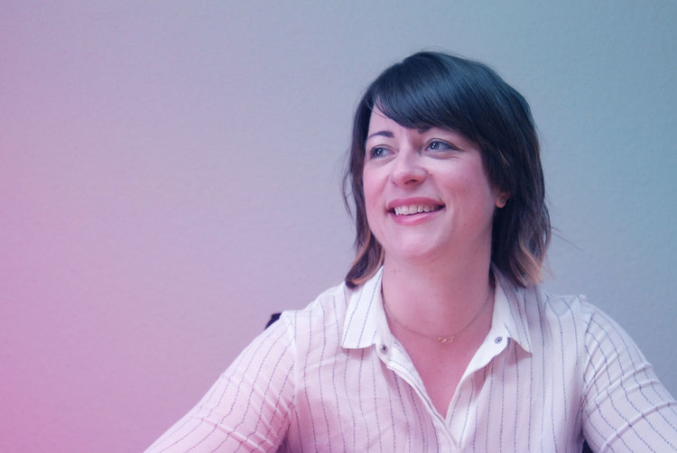
Heledd Bebb is a director and co-owner of OB3 - one of Wales' leading research and evaluation companies. OB3 utilises quantitative and qualitative research techniques to provide astute insights and pragmatic recommendations to a range of public and third sector clients across diverse policy areas.
Prior to that, Heledd was one of the first academic appointments of the Coleg Cymraeg Cenedlaethol. She was Senior Lecturer in Business and Management at the University of South Wales and Cardiff Metropolitan University where she used innovative approaches to establish and expand provision and attracted high numbers to study through the medium of Welsh for the first time there.

Dr Kelly Young
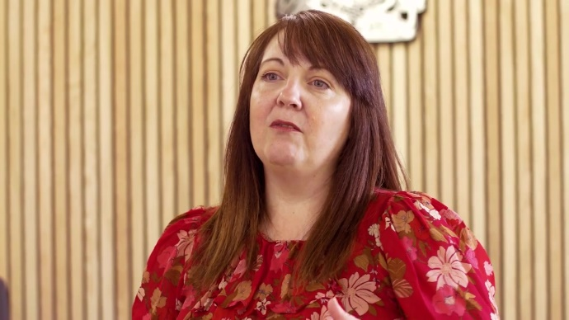
Kelly is Senior Lecturer and Director of the BA (Hons) Business and Management Program at Cardiff Metropolitan University.
As an FE lecturer, Promoter of Bilingualism and more recently, HE Senior Lecturer, she has experience of co-ordinating and leading Welsh language promotion projects among post-16 students up to postgraduate.
Kelly's doctorate is based on testing bilingual learning methodology, and specifically, building confidence and improving students' language skills, including bilingual learning methods.

Dr. Osian Elias
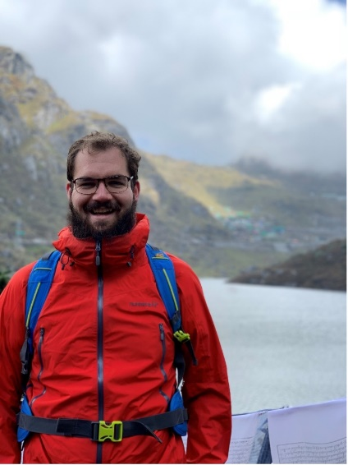
Osian completed his doctorate on behaviour change and language policy at Aberystwyth University in 2017. He lectured in human geography at Swansea University until 2023, when he joined IAITH as Director of Behaviour Change and Language Policy.
As well as applying behavioural change methods to language policy, Osian enjoys interdisciplinary work. He is currently working on a project that looks at the temporary use of language exploring the phenomenon of the Pop Up Gaeltacht in Ireland under the auspices of the Saunders Lewis Memorial Fund.

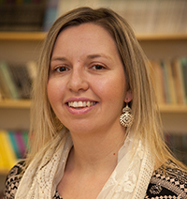

Dr Rhian Hodges
Dr Rhian Hodges is a Senior Lecturer in the field of Sociology and Social Policy at Bangor University's School of History, Law and Social Sciences.
Her research is often around linguistic policy and planning and she’s responsible for the M.A Linguistic Policy and Planning at Bangor University.
Her research interests include new Welsh speakers and their language journeys, Welsh-medium education, and the transmission and use of the Welsh language in many different spheres such as the family and the community.

Menna Jones
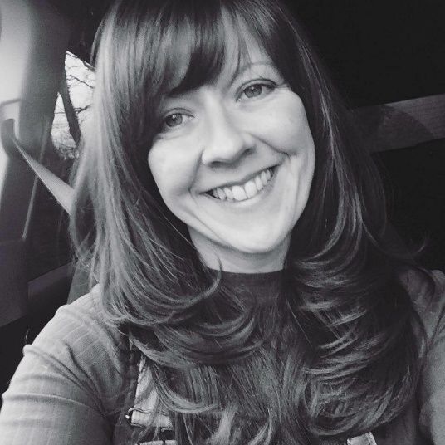
Menna Jones has been the Regional Language Officer at Coleg Sir Gâr since 2020. Before that, she worked in the Student Services department at the University of Wales Trinity Saint David in Carmarthen. During her career, she has worked in various fields including events organiser, social media/marketing and primary school teacher for 15 years.
She is very interested in the world of sport and received a first class degree in Sports and Exercise Science in 2019.

Anna Fflur Davies
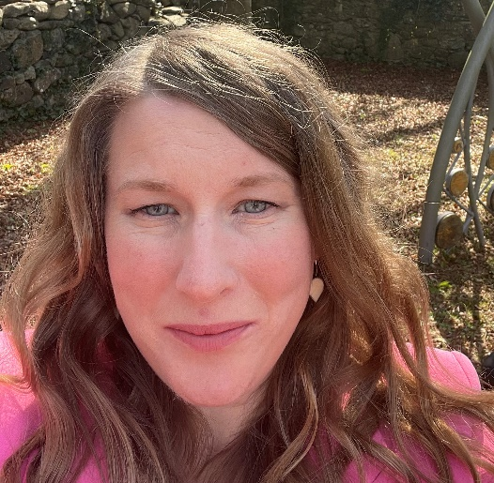
Anna has been working as the Welsh Language Manager at Swansea's Gower College for over 10 years. Originally from Llanfairpwll, Anglesey, she now lives in Cardiff and works in Swansea.
She works across all campuses in the college developing a bilingual and Welsh curriculum in the areas of Further Education and Higher Education.
In addition to that, she works with various students to give them opportunities to develop and continue with their Welsh skills, whatever their language level.

Mary Richards
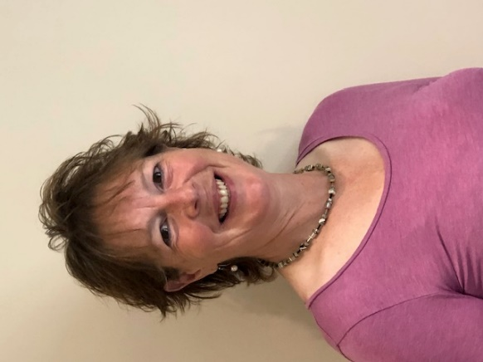
Mary works part-time for the Coleg Cymraeg Cenedlaethol as an e-learning specialist following a period working for them as an agricultural specialist.
Before that, she was responsible for the land studies department at Coleg Sir Gâr.
She won the Colegau Cymru Lecturer of the Year award in 2015 and is interested in technology, farming and sport, especially golf.

Marion Evans
Marion has worked for Bridgend College since 2017, mainly teaching psychology, sociology and anatomy and physiology. Marion presents some units bilingually on the Access to Higher Education course, enabling learners to develop their Welsh skills.
Being a bilingual lecturer empowers Marion's colleagues and learners. She is also a Staff Governor and an experienced A Level Examiner.

Meggan Prys
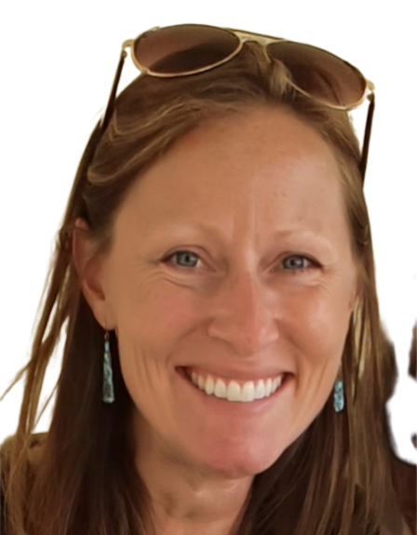
Meggan has been working for Sgiliaith, Grŵp Llandrillo Menai, as a collaborative PLF (Professional Learning Fund) Project Manager on bilingualism since 2020.
The project focuses on supporting post-16 tutors to develop bilingual teaching skills by providing training, developing resources and creating opportunities for tutors to network and share good practice.

Dr Mirain Rhys
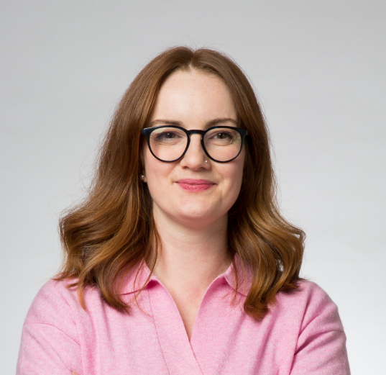
Dr Mirain Rhys is Senior Lecturer in Psychology and Strategic Leader of the Welsh Language at Cardiff Met University.
Her expertise covers the fields of Education and Bilingualism. Her current research interests are in the development / transmission of the Welsh language within education, the community and the home and how this compares with other international examples of minority language populations.

She has carried out research and published papers on numerous subjects, including early years education, bilingualism, minority languages ​​and the Welsh language.

Dr Dylan Foster Evans
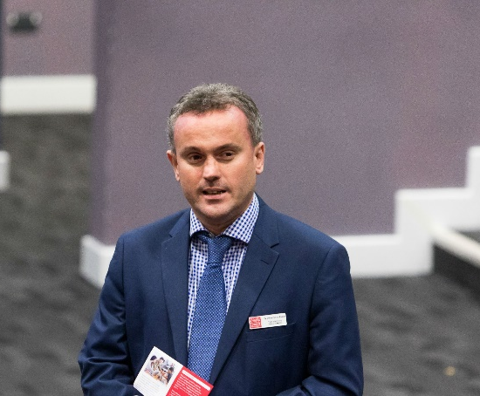
Dylan is Head of the Welsh Language School at Cardiff University and poetry of the late Middle Ages is his main area of ​​expertise.
His interest in language and place extends to the modern period and he has a particular interest in the Welsh language in Cardiff. His work in this area deals with the history of the language, its culture and literature and also its role in the formation of identity in a diverse and multi-ethnic city. Place names form another related area of ​​interest.
More generally, he’s interested in the role of the Welsh language in the education system and the different types of Welsh used in contemporary Wales.

