# Pathways to the workplace: A vision for Welsh-medium and bilingual tertiary education, 2026 to 2030

# Overview

**The Welsh language belongs to us all.**

That is why Welsh Government has a vision to make the Welsh language an integral part of our everyday lives and to boost the number of people who speak it to one million.

At the heart of the Cymraeg 2050 strategy – and the Senedd’s support for it – is a desire to throw wide open the doors to the Welsh language.

For that to happen, young people must be given opportunities to use their Welsh with confidence.

The Coleg Cymraeg Cenedlaethol has a vision of a Wales in which every learner uses, maintains and develops their Welsh language skills in education, and then in the workplace.

Success relies on creating more opportunities and providing more support and encouragement.

Ahead of the Senedd election in 2026, we call on the next government of Wales to set two aims:

* To boost the number of learners who follow Welsh and bilingual pathways throughout the education system, especially the tertiary sector.
* To boost the number of people who can and who choose to work bilingually, including within the education workforce.

If the next government is to achieve both aims, it needs to take six steps. These are the Coleg Cymraeg Cenedlaethol’s six proposals for realising the ambition of Cymraeg 2050 for a prosperous, bilingual nation where the Welsh language flourishes in education, in work and in everyday life.

# Executive summary

These are the aims and proposals that the Coleg Cymraeg Cenedlaethol calls on the next Welsh Government to adopt and implement.

**Aim 1: Increase the number of learners who study and train in Welsh and bilingually.**

* **Proposal 1.1:** Align the tertiary education sector more closely with Welsh Government strategic priorities.
* **Proposal 1.2:** Fund the Coleg Cymraeg Cenedlaethol in order to ensure more learners can follow a seamless pathway in Welsh or bilingually.
* **Proposal 1.3:** Boost the number of Welsh language and bilingual apprenticeships through additional investment.
* **Proposal 1.4:** Assign special status to Welsh as a subject.

**Aim 2: Increase the number of people who enter the workplace able to work bilingually.**

* **Proposal 2.1:** Create a Bilingual Workforce Development Strategy and establish a Unit within government to implement it.
* **Proposal 2.2:** Direct and fund Medr and the Coleg Cymraeg Cenedlaethol to ensure the requirements of the Bilingual Workforce Development Strategy are implemented in the tertiary sector.

# Aim 1

**Increase the number of learners who study and train in Welsh and bilingually.**

Deliberate action is needed now to ensure more learners continue to learn in Welsh or bilingually – through the education system as a whole and particularly in the tertiary sector.

Positive changes are on the way as a result of the Welsh Language and Education Bill and the National Plan for the Welsh language that Medr will oversee, but we must take steps now to create opportunities and momentum. If we do not, in the face of unprecedented cuts to the tertiary sector, we are in grave danger of losing ground.

**Figure 1: A large percentage of learners stop learning through the medium of Welsh at every key stage in their education, leading to many learners entering the workforce unable to work bilingually.**



## Proposal 1.1

**Welsh Government should align the tertiary education sector more closely with its strategic priorities.**

To contribute to the government’s ambition of creating a prosperous, bilingual nation, it is necessary to recruit, motivate and train new staff for the tertiary education sector, keep learners in Wales, encourage them to gain skills by learning in Welsh or bilingually, and prepare them to work in areas that are economic and community priorities – including the ability to work bilingually.

To make this happen, Welsh Government must be prepared to plan and invest more strategically.

After the election, Welsh Government should set out a new statement of priorities for Medr which:

* Ties more closely the way in which Medr uses its financial and regulatory powers with the government’s wider priorities, including the Cymraeg 2050 targets.
* Contributes towards implementing the recommendations of the Commission for Welsh-speaking Communities.

Welsh Government should also:

* Ensure that other funding bodies such as Health Education and Improvement Wales (HEIW) acknowledge the higher costs of Welsh language provision and take this into account when commissioning courses that contribute towards building a bilingual workforce.
* Set a target to increase the number of Seren Academy students who go on to study through the medium of Welsh in Welsh universities.

## Proposal 1.2

**Welsh Government should provide additional funding to the Coleg Cymraeg Cenedlaethol to ensure more learners can follow a seamless pathway in Welsh or bilingually.**

We can create seamless pathways for learners by:

* Creating a series of incentive schemes to recruit staff from within and outside the tertiary education sector, and development plans for early-career academics in the higher education sector.
* Investing to protect existing provision, to expand that provision to reach more learners – including Welsh-medium provision in vocational subjects – and to establish provision in new subjects.
* Funding the Coleg Cymraeg to widen the appeal of Welsh-medium and bilingual provision to new audiences, including through evidence-based behaviour change schemes targeted at specific groups of learners.
* Ensuring Medr encourages demand for Welsh-medium and bilingual education in under-represented groups, and supports them to choose Welsh-medium and bilingual study – with particular emphasis on Black, Asian and ethnic minority learners and learners who live in the most deprived areas.

The aim is to open the door wider still, boost opportunities and make learning – and teaching – in Welsh more attractive to everyone. Progress should be measured and monitored every step of the way.

**Figure 2: Only 2.1% of the tertiary education budget* is spent on Welsh medium**

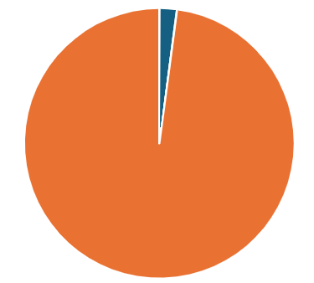

* Excluding sixth forms (data: Welsh Government, Medr)

## Proposal 1.3

**Welsh Government should boost the number of Welsh language and bilingual apprenticeships through additional investment.**

A strategic plan is needed to increase opportunities for apprentices to maintain and develop their skills in Welsh, particularly in areas where there is demand for bilingual workers and where young people are eager to live and work in their communities.

Welsh Government should support and provide funding for the Coleg Cymraeg Cenedlaethol to work with other national partners to map the current situation, to measure both employer and user demand, and to target priority sectors to create more Welsh and bilingual apprenticeships.

A strategic plan would:

* Place more stringent conditions relating to Welsh language provision on apprenticeship providers, and monitor compliance.
* Ensure there are bilingual tutors, assessors and mentors in the right sectors – and areas – to support the apprentice every step of the way.
* Place apprentices who speak Welsh on Welsh-medium or bilingual pathways.
* Link the call for skilled bilingual workers in specific parts of the economy with graduate apprenticeships.

We also call on Welsh Government to:

* Give strategic direction to Medr and Qualifications Wales so that the necessary standards, frameworks and qualifications are available in Welsh and bilingually.

**Figure 3: Map showing percentage of Welsh speakers in different areas of Wales.**

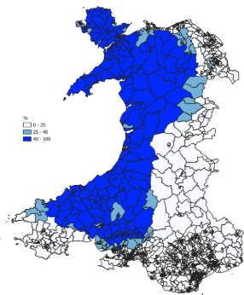To reach Cymraeg 2050 targets, more skilled bilingual workers will be required across Wales and particularly in areas with a higher proportion of Welsh speakers.

(source: [Commission for Welsh-speaking Communities](https://www.gov.wales/sites/default/files/publications/2024-08/empowering-communities-strengthening-the-welsh-language.pdf))

## Proposal 1.4

**Welsh Government should assign special status to Welsh as a subject.**

Fewer learners are studying Welsh A level, and far fewer are studying Welsh Second Language to the same level. Fewer English medium and bilingual schools offer Welsh Second Language to A level.

Welsh Government wants to see growth and to realise the ambition of the Cymraeg 2050 strategy. Therefore, the next government must protect the Welsh language as a subject at each level in the tertiary sector, so that all learners have the chance to master the language and study it to degree level.

We call on Welsh Government to:

* Make it a strategic priority for Medr to protect Welsh as a subject at each level.
* Place an expectation on local authorities to ensure that each and every eligible learner is given an appealing opportunity to study Welsh up to A level.
* Provide extra funding for the Coleg Cymraeg to develop and lead a new national strategy to increase the number of learners who carry on studying Welsh, to promote the value of Welsh as a skill in the workplace, to support centres so they can offer the subject, and to recognise and respond to the different needs of teaching Welsh as a first and second language.

**Figure 4: A level entries in Welsh and Welsh Second Language**

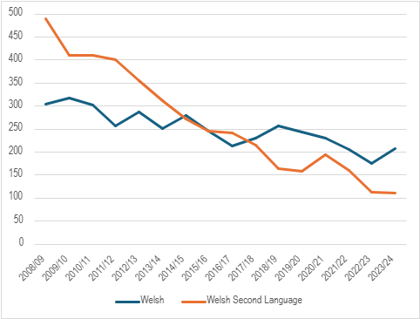

(data: [StatsWales](https://statswales.gov.wales/Catalogue/Education-and-Skills/Schools-and-Teachers/Examinations-and-Assessments/Advanced-Level-and-Equivalent/alevelentriesandresultspupilsaged17only-by-subjectgroup))

# Aim 2

**Increase the number of people who enter the workplace able to work bilingually.**

Everyday-life areas such health, social work, childcare and education – and sectors that play a vital role in developing the Welsh economy – are crying out for more bilingual workers.

This requires a vigorous, co-ordinated response at national level, rooted in evidence about sectoral needs.

## Proposal 2.1

**Welsh Government should create a Bilingual Workforce Development Strategy and establish a Unit within government to implement it.**

Such a strategy would:

* Adopt a long-term vision, with ambitious targets, in order to achieve the objectives of the Cymraeg 2050 strategy.
* Prioritise the development of the bilingual teaching workforce. Only then can we ensure an adequate supply of bilingual workers in key sectors.
* Identify other areas where demand is highest in terms of public service, and where the Welsh language can be an important economic driver, e.g. the green economy, agriculture, commercial services, the creative industries and tourism.
* Identify areas of Wales where the demand or potential for a bilingual workforce is strongest, and the most effective way of promoting that growth.
* Gather and analyse data continuously to measure progress and target planning.

The Bilingual Workforce Development Strategy Unit would monitor progress and ensure accountability across Welsh Government departments.

The Unit would also establish collaboration arrangements with regulators, professional bodies, providers and employers. It would work with the Welsh Language Commissioner to promote Welsh in the workplace (including through implementing Welsh language and sharing good practice). It would cooperate with the National Centre for Learning Welsh/Yr Athrofa to support schemes to develop Welsh language skills in specific workplaces.

## Proposal 2.2

**Welsh Government should direct and fund Medr and the Coleg Cymraeg Cenedlaethol to ensure the requirements of the Bilingual Workforce Development Strategy are implemented in the tertiary sector.**

Each of the six proposals for the next government of Wales in this document paves the way towards a confident, bilingual workforce.

To succeed, the tertiary sector has to respond with equal energy and purpose to increase opportunities and provide encouragement to staff and learners from all backgrounds.

Under the leadership of Medr and the Coleg Cymraeg, the tertiary sector needs to:

* Integrate Welsh-medium content into its provision, in co-operation with professional/sectoral bodies and regulators, as necessary.
* Ensure that education and training is planned strategically, and provide adequate funding to courses in priority fields and areas.
* Organise effective national promotion and recruitment campaigns to attract the greatest possible number of suitable learners – and educators.

# Contact details

If you’d like to discuss our proposals or would like more detailed information about specific elements, please contact [polisi@colegcymraeg.ac.uk](mailto:polisi@colegcymraeg.ac.uk)